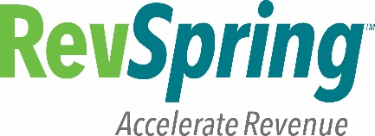

**Certification of Understanding**

Compliance & Ethics’ Program Training - 2017

I have viewed the following compliance & ethics’ training modules:

* Compliance & Ethics’ Program Training
  + **Part I – The Program and its 8 elements**
  + **Part II - Regulatory Landscape (Summary of various regulations)**
  + **Part III - HIPAA Privacy & Security/Consumer Financial Protection Bureau**
  + **Part IV – Key Lessons including Standardized Practices**

Each year, RevSpring is required to provide compliance & ethics’ program training for all employees, temporary employees and contractors. By viewing the training slides, I confirm that I am fully aware of the content and now have a basic understanding of the various regulations that cover RevSpring’s services. I am also aware that I must follow RevSpring’s Standards of Conduct which are the foundation of the compliance & ethics’ program. Further, it is my responsibility to help prevent, detect and correct any legal and ethical wrongdoings whenever possible.

I certify that I viewed the entire compliance & ethics program presentation for 2017.

**NAME**: Pravallika Gongati________________________________

**DEPARTMENT**: Configuration Analysts___________________________

**SIGNATURE**: ____________________________________________

**DATE**: 02/09/2018_______________________________________